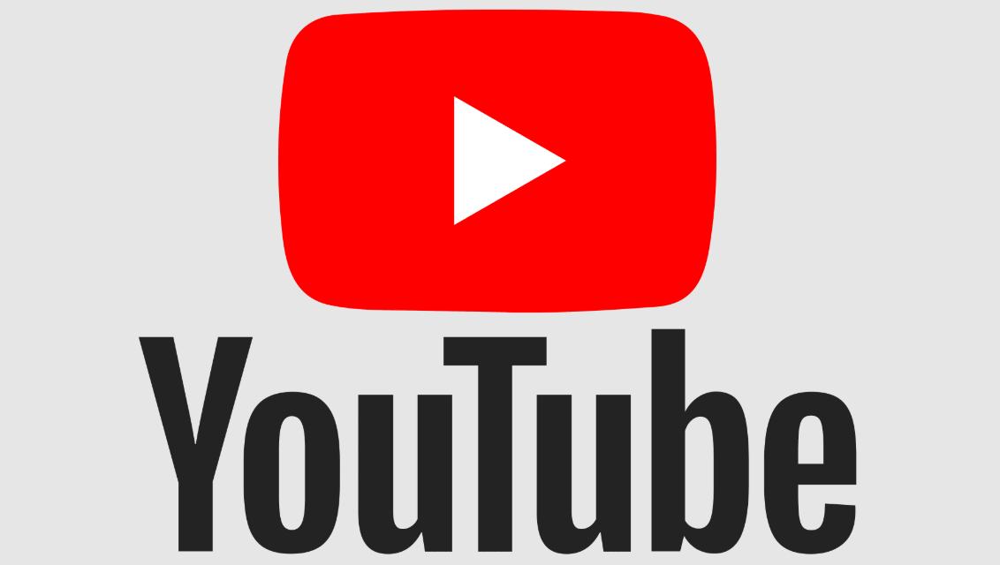

**Part 1**

**Product Dissection**

**1. Platform Selection**

**Question**: Choose a leading platform from a domain related to the entertainment industry. Justify your selection by discussing the platform's popularity, impact, and relevance in its industry.

**Answer: Youtube**

YouTube is a leading video-sharing platform that has revolutionized digital entertainment and content marketing. It is highly relevant to the entertainment industry as it serves as a critical medium for businesses to promote products, connect with customers, and generate sales through video content.

    Popularity: YouTube has over 2.7 billion active users worldwide, making it one of the most visited websites globally.

    Impact: It provides a platform for influencers, brands, and individuals to create engaging content, increasing brand visibility and consumer trust.

    Relevance: With features like product links in video descriptions, targeted ads, and integrated shopping features, YouTube serves as a bridge between entertainment and e-commerce.

**2. Core Features and Functionalities**

**Question:** Research and list the core features and functionalities of the selected platform. Describe how these features contribute to the platform’s success and user engagement.

**Answer**: Video Uploading and Sharing: Allows creators to upload content in various formats, enabling anyone to share ideas, reviews, or tutorials.

 Impact: Democratizes content creation and expands user engagement.

**Recommendation Algorithm**: Suggests videos based on user behavior and preferences.

 Impact: Drives user retention and ensures a personalized viewing experience.

**Monetization Tools**:

        Ad revenue sharing (AdSense)

        Memberships and Super Chat

        Affiliate links and sponsorships

        Product tagging (Shopify integration)

**Impact:** Incentivizes creators and promotes economic activity within the ecosystem.

**YouTube Ads**: Supports targeted advertisements like TrueView, discovery ads, and non-skippable ads.

        Impact: Offers brands a way to reach millions of potential customers effectively.

**Live Streaming**: Real-time interaction with viewers through comments, live Q&A, and events.

        Impact: Builds engagement and community trust, especially for product launches.

**Analytics Dashboard**: Provides creators and brands insights into video performance (views, watch time, demographics).

        Impact: Helps optimize content and marketing strategies.

**Integration with E-commerce Platforms:** Enables users to buy products directly via ads or links in the video description.

**Impact**: Drives direct sales conversions and enhances the shopping experience.

**3.  Real-World Problems**

### Problem 1: Copyright Violations

#### Description:

YouTube faces ongoing issues with users uploading copyrighted material without permission, leading to legal challenges and revenue disputes.

#### Solution:

* **Content ID Improvements:** Refine the Content ID system to better detect and manage copyrighted material.
* **Creator Education:** Educate users about copyright laws and fair use policies.
* **Fair Revenue Sharing:** Develop policies for fair revenue sharing between creators and copyright holders.
* **Legal Partnerships:** Strengthen partnerships with copyright organizations to streamline claim resolutions.

### Problem 2: Misinformation and Fake News

#### Description:

YouTube has been criticized for being a platform where misinformation spreads rapidly. Videos promoting conspiracy theories or false information can harm society and erode trust.

#### Solution:

* **Algorithmic Moderation:** Enhance AI algorithms to detect and downrank videos with misinformation.
* **Fact-Checking Partnerships:** Collaborate with verified fact-checking organizations to review flagged content.
* **User Reporting Mechanisms:** Strengthen and simplify user reporting tools to identify misleading content.
* **Educational Initiatives:** Promote videos from credible sources and label them with badges to distinguish them as verified.

### Problem 3: Monetization Inequalities

#### Description:

Small creators often struggle to earn revenue due to strict monetization thresholds and revenue-sharing disparities.

#### Solution:

* **Lower Entry Barriers:** Reduce the eligibility criteria for monetization for smaller creators.
* **Flexible Monetization:** Introduce tiered monetization models based on the creator’s size and engagement.
* **Ad Revenue Transparency:** Provide clearer breakdowns of ad revenue sharing.
* **Support for Niche Creators:** Develop specific programs to boost visibility and earnings for niche content creators.

**Problem 4: Data Privacy Concerns**

**Description:**

YouTube collects significant user data for personalized experiences, raising concerns about privacy and potential misuse.

**Solution:**

**Privacy-First Policies**: Limit data collection to what is necessary and provide users with detailed explanations of data usage.

**User Contro**l: Allow users to easily control and delete their data through their account settings.

**Third-Party Audits**: Regularly audit YouTube’s data handling practices through independent organizations.

**Child Safety Measures**: Comply with regulations like COPPA to ensure children's data privacy is prioritized.

**4. Database Management & Schema Design**

**Question:** Utilize tools like the Miro platform or similar applications to create an illustrative Entity-Relationship (ER) diagram. This diagram should vividly depict the entities, attributes, and relationships present within your schema design.

**Answer:**

The key entities for YouTube would include:

**Users:**

        Attributes: User_ID, Name, Email, Subscription_Type, Join_Date

**Videos:**

        Attributes: Video_ID, Title, Description, Upload_Date, Creator_ID, Category

**Creators:**

        Attributes: Creator_ID, Name, Channel_Name, Subscriber_Count

**Comments:**

        Attributes: Comment_ID, Video_ID, User_ID, Text, Comment_Date

**Ads:**

        Attributes: Ad_ID, Video_ID, Advertiser_ID, Clicks, Views, Revenue

**E-commerce Integration:**

        Attributes: Product_ID, Video_ID, Clicks, Purchases, Revenue

**Relationships:**

    A user can upload multiple videos.

    A video can have multiple comments.

    An advertiser can sponsor multiple ads linked to videos.

    A video can promote multiple products.

**5. Revenue and Profit Growth Strategies**

**Question**: After completing the product dissection and schema design steps for the chosen platform, conduct a comprehensive case study on the above chosen industry. Your goal is to identify and propose strategies to increase the profit of the industry by at least 25%.

**Answer:**

Strategies to Increase Revenue by 25%:

**Expand Product Integration for E-commerce:**

        Enable seamless integration with major e-commerce platforms (e.g., Amazon, Shopify).

        Use AI to recommend products based on viewer behavior.

**Increase Ad Effectiveness:**

        Enhance the recommendation algorithm to show highly targeted ads.

        Introduce AI-based personalized ads with higher click-through rates (CTRs).

**Premium Subscription Expansion**:

        Promote YouTube Premium with exclusive content and additional features like shopping discounts.

**Enhanced Analytics for Businesses:**

        Provide advanced analytics tools to advertisers for better campaign optimization.

**Invest in Emerging Markets:**

        Increase platform accessibility in developing regions to onboard more users and advertisers.

**Introduce Tiered Monetization for Creators:**

        Offer premium-tier monetization plans based on audience engagement and reach.

**Leverage AI for Real-time Engagement:**

        Use AI to automatically tag products in live streams or videos, enabling instant purchase.

**Launch New Ad Formats:**

        Introduce immersive 360-degree video ads and shoppable ads for greater engagement.

**Timeline:**

    Months 1-3: Implement enhanced analytics and introduce new ad formats.

    Months 4-6: Develop AI-powered product tagging and shoppable video features.

    Months 7-12: Expand partnerships with e-commerce platforms and target emerging markets.

**Resources:**

    Data scientists for AI feature development.

    Marketing team for Premium subscription promotions.

    Development team for feature integration.

**Visual Aids:**

    Charts: Show potential increase in ad revenue and Premium subscriptions.

    Diagrams: Display workflow of AI-based product tagging.

### Schema Description:

### The YouTube schema covers a range of entities that represent different aspects of the platform. These entities include Channels, Videos, Comments, Likes, Subscribers, Playlists, and others. Each entity is defined by particular attributes that describe its characteristics and the relationships it has with other entities.

### Channel Entity:

YouTube channels are central to content creation, serving as a hub for creators to upload their videos. This entity holds important details about each channel and its attributes.

1. **ChannelID (Primary Key)**:  
   A distinct identifier that uniquely identifies each channel.
2. **ChannelName**:  
   The name given to the channel, which is displayed publicly.
3. **Email**:  
   The email address linked to the channel, used for communication purposes.
4. **Owner_Name**:  
   The full name of the individual or group managing the channel.
5. **Description**:  
   A brief text written by the channel owner to explain the channel's purpose and content.
6. **Creation_Date**:  
   The exact date when the channel was established on YouTube.

### Video Entity:

Videos are the content uploaded by creators for viewers to watch. This entity tracks all the details about each individual video.

1. **VideoID (Primary Key)**:  
   A unique identifier assigned to every video on the platform.
2. **ChannelID (Foreign Key referencing Channel Entity)**:  
   Identifies the channel to which the video belongs.
3. **Title**:  
   The title of the video, providing a name or description for the content.
4. **Video_URL**:  
   The URL link to the video on YouTube.
5. **Description**:  
   A detailed description or summary of the video’s content.
6. **Upload_Date**:  
   The date when the video was first uploaded to the platform.

### Subscription Entity:

This entity manages information about user subscriptions to channels, allowing users to follow and receive updates from their favorite creators.

1. **SubscriptionID (Primary Key)**:  
   A unique identifier for each subscription record.
2. **SubscriberID (Foreign Key referencing User Entity)**:  
   The ID of the user who has subscribed to a channel.
3. **ChannelID (Foreign Key referencing Channel Entity)**:  
   The ID of the channel that the user has subscribed to.
4. **Subscription_Date**:  
   The date when the user initially subscribed to the channel.

### Notification Entity:

Notifications are triggered for users when events, such as new video uploads, occur. This entity captures the details of each notification sent to users.

1. **NotificationID (Primary Key)**:  
   A unique identifier for each notification that is sent to users.
2. **RecipientUserID (Foreign Key referencing User Entity)**:  
   The ID of the user receiving the notification.
3. **SenderUserID (Foreign Key referencing User Entity)**:  
   The ID of the user who triggered the notification, such as by uploading a new video.
4. **Notification_Date**:  
   The date when the notification was created and sent to the recipient.

### Like Entity:

Likes are actions taken by users to show appreciation for videos. This entity tracks each like given to videos on the platform.

1. **LikeID (Primary Key)**:  
   A unique identifier for each like given to a video.
2. **VideoID (Foreign Key referencing Shorts Entity)**:  
   The ID of the video that received the like.
3. **UserID (Foreign Key referencing User Entity)**:  
   The ID of the user who liked the video.
4. **Like_Date**:  
   The date when the like was registered.

### Comment Entity:

Comments allow users to engage with videos by posting feedback or participating in discussions. This entity stores details about each comment.

1. **CommentID**:  
   A unique identifier assigned to each comment.
2. **VideoID (Foreign Key referencing Video Entity)**:  
   The ID of the video being commented on.
3. **UserID (Foreign Key referencing User Entity)**:  
   The ID of the user who posted the comment.
4. **Text**:  
   The content of the comment left by the user.
5. **Comment_Date**:  
   The date when the comment was posted.

### YouTube Shorts Entity:

YouTube Shorts is a feature for short-form videos. This entity records all necessary details about each Shorts video.

1. **ShortsID (Primary Key)**:  
   A unique identifier for each Shorts video.
2. **ChannelID (Foreign Key referencing Channel Entity)**:  
   The channel that uploaded the Shorts video.
3. **Title**:  
   A brief description or title for the Shorts video.
4. **Shorts_URL**:  
   The URL that links directly to the Shorts video.
5. **Description**:  
   Additional information or context about the Shorts video.
6. **Upload_Date**:  
   The date when the Shorts video was uploaded to YouTube.

**Relationships are:**

* **Content creators upload videos:** Each channel can upload numerous videos.
* **Users comment on videos:** Users can leave comments on various videos, and each video can have multiple comments.
* **Users like videos:** Users have the option to like many videos, and each video can receive multiple likes.
* **Users subscribe to channels:** Users can subscribe to many channels, and each channel can have multiple subscribers.
* **Videos feature hashtags:** Videos can include many hashtags, and each hashtag can be associated with multiple videos.

**ER Diagram:**

Let's create an ER (Entity-Relationship) diagram that visually illustrates the relationships and attributes of the entities within the YouTube schema. This diagram will provide a clear visual representation, highlighting the essential components of YouTube's data model. Utilizing this diagram will enhance your understanding of the intricate connections and interactions that shape the dynamics of the platform.

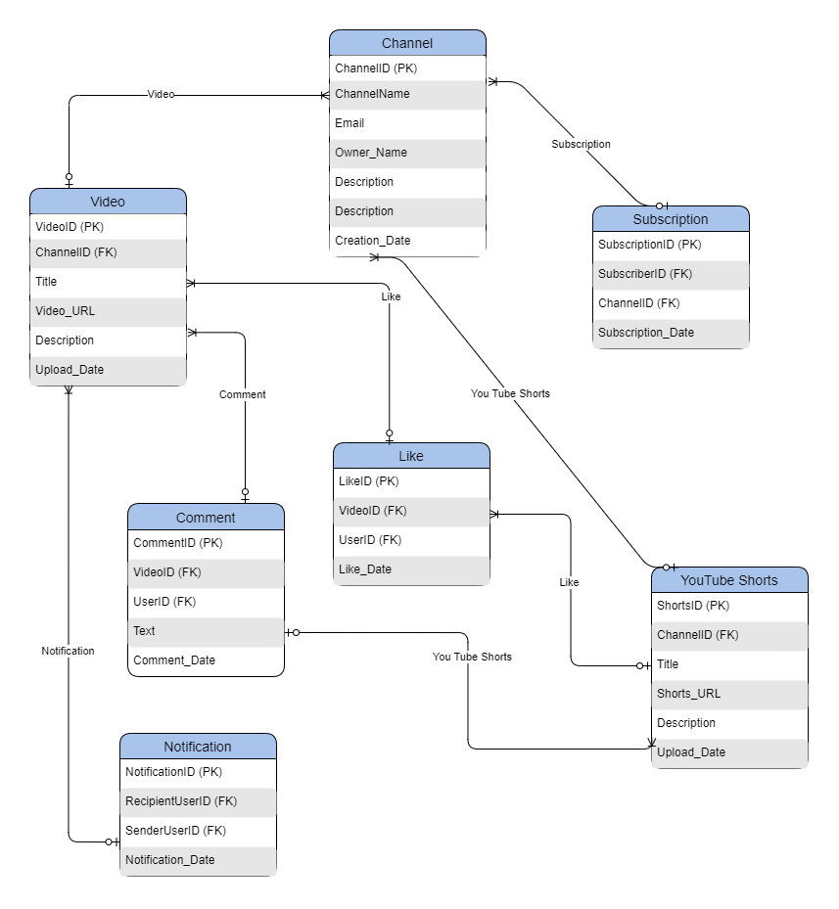

**PART-2**

**1.What will be the percentage increase in global streaming service subscriptions over the next five years?**

ANS-Case Study: Projecting YouTube’s Role in the Growth of Global Streaming Subscriptions

YouTube’s Growth Trajectory  
YouTube, one of the largest streaming platforms globally, has shown exponential growth since its inception. By 2023, YouTube had over 2.6 billion monthly active users and more than 80 million subscribers to its premium services like YouTube Premium and YouTube Music​.This growth reflects the increasing reliance on video streaming for both entertainment and education.

### Projected Growth in Subscriptions

Premium Services:

YouTube’s premium subscriptions, including ad-free viewing and music streaming, are expected to grow rapidly. This growth is bolstered by rising internet penetration, particularly in developing markets like India and Africa, where YouTube is introducing localized content to capture new users.

With a CAGR of approximately 7–10%, YouTube Premium subscriptions alone could increase by 40–50% over the next five years, reaching upwards of 120 million subscribers globally.

Content Diversity:

YouTube’s mix of user-generated and professional content ensures consistent engagement. Exclusive content offerings, such as original series, along with its dominance in educational and tutorial videos, help it retain its competitive edge over platforms like Netflix and Amazon Prime.

Monetization via Ads:

Unlike traditional subscription models, YouTube’s primary revenue still comes from ad monetization. As global digital ad spending grows, YouTube’s ad-based viewers are likely to increase by 20–25% over five years, further consolidating its position as a leader in the streaming ecosystem.

**2.How many hours of content will the average person consume per week through digital platforms in 2025?**

ANS-By 2025, the average person is expected to consume between 28 and 33 hours of digital content per week across various platforms, reflecting the increasing dominance of video streaming, music streaming, and other digital media formats.

YouTube Usage Trends:

Globally, YouTube users watch over 1 billion hours of content daily. This engagement is driven by the platform’s wide range of video formats, including live streams, tutorials, entertainment, and short-form videos​.  
  
In 2023, individuals spent about 17 hours weekly on digital videos, and this is projected to increase to approximately 21 hours by 2025 as the consumption of video-based content continues to rise​.

Broader Digital Media Growth:

In the U.S., adults are predicted to spend nearly 8 hours daily on digital media by 2025, with approximately 4 hours of this dedicated to video content. Weekly, this totals 28 hours for digital video alone, which includes platforms like YouTube​.

Factors Contributing to Growth:

Mobile and Connected Devices: Over 50% of YouTube watch time is on mobile, and connected TVs are gaining traction. This multi-device engagement increases average viewing hours per user.

Content Variety: YouTube offers both short-form and long-form videos, catering to diverse user preferences, contributing to its high average session lengths of over 40 minutes​.

These projections indicate that digital platforms, led by YouTube, will continue to dominate user attention, with weekly consumption surpassing 30 hours for many users by 2025.

**3.What will be the market share of virtual reality (VR) and augmented reality (AR) entertainment experiences in the next decade?**

Virtual reality (VR) and augmented reality (AR) are poised to revolutionize entertainment, including platforms like YouTube, over the next decade. By 2033, the market share for AR and VR in entertainment is projected to grow significantly, driven by advancements in technology, increased consumer adoption, and the expansion of immersive content.

### Projected Market Growth

Market Share Projections:

The global AR and VR market is estimated to surpass $65 billion by 2033, with entertainment representing a substantial portion of this growth. The segment for gaming, live events, and interactive storytelling will dominate due to consumer demand for immersive experiences​.  
  
Location-based VR entertainment alone, which includes VR arcades and theme parks, is expected to grow at a compound annual growth rate (CAGR) of 28.3%, reflecting increasing public engagement with VR environments​.

YouTube and Immersive Content:

YouTube has already integrated VR capabilities, allowing users to explore 360-degree videos. These features are anticipated to expand, especially as VR devices become more affordable and accessible.

With the growing trend of live-streamed VR events, YouTube could capitalize on AR and VR technologies to maintain its leadership in digital video platforms​.

### Key Drivers of Growth

Hardware Improvements: The development of advanced headsets, AR glasses, and interactive controllers will make VR and AR more appealing to consumers​.  
  
Content Diversification: Platforms like YouTube are likely to host more AR and VR-compatible content, including educational, gaming, and cinematic experiences, to attract broader audiences​.  
  
Consumer Adoption: As users grow accustomed to VR for gaming and social interaction, demand for such technologies in entertainment will increase​.

Challenges

While growth is promising, barriers like high hardware costs, content production expenses, and user adoption rates could slow progress. Nonetheless, with increasing investments from companies like Alphabet, YouTube's parent company, immersive experiences will likely become a core part of entertainment by the next decade.

By 2033, AR and VR are expected to secure a significant foothold in the entertainment industry, redefining how platforms like YouTube engage users.

**4.How many new films and TV shows will be produced globally per year by 2030?**

Ans-By 2030, the global production of films and TV shows is expected to increase significantly, fueled by rising demand from streaming platforms and advancements in digital production technologies. Key trends include-

Content Production Growth:

In 2020, global spending on content production reached a record $220 billion, and this trajectory is expected to accelerate. By 2030, annual production levels could exceed tens of thousands of films and a substantial number of TV series as streaming services like YouTube, Netflix, and Disney+ continue expanding their libraries.

India and China, as leading content producers, alongside Hollywood, will contribute heavily to this growth, with markets like Nollywood also gaining prominence.

YouTube’s Role:

YouTube, already a dominant player, has expanded into original productions with YouTube Originals and creator-driven content. With lower production barriers, it enables thousands of creators to produce serialized or episodic content, effectively adding to global production volumes.

Emerging Markets:

The rise of localized content in Africa, Latin America, and Asia is contributing to the growth of new productions. These regions are increasingly leveraging cost-effective technologies to cater to local and global audiences.

While precise numbers vary, experts predict that by 2030, the global number of new films and TV series produced annually will grow by at least 30-50%, driven by streaming demand and diversified markets. YouTube's creator economy and its global accessibility will play a key role in shaping these trends.

**5.What percentage of global box office revenue will be generated by international markets in the next five years?**

In the next five years, the majority of global box office revenue will continue to be generated by international markets. This trend reflects the increasing globalization of cinema and the growing significance of emerging markets in Asia, particularly China and India, where box office revenues are experiencing rapid growth.

International Market Dominance:

By 2028, international markets are projected to contribute over 70% of global box office revenue, a consistent trend from recent years where the share of revenue outside North America has steadily risen. The U.S. and Canada typically account for about 25-30% of global box office earnings, with the remaining share coming from international markets.

Key Regional Contributions:

Asia, led by China, is expected to dominate international box office revenues, contributing significantly due to high population density and the increasing popularity of local and Hollywood films. India, with its booming film industry, will also play a critical role.

Other regions, including Europe and Latin America, are also growing contributors, particularly for major franchise films and regional hits.

Streaming and Theatrical Hybrid Models:

The integration of streaming platforms and theatrical releases is expected to influence box office dynamics, especially in emerging markets where digital adoption is high. These hybrid models can complement traditional box office revenue streams.

The continued emphasis on international markets underscores the global appeal of cinematic content and the importance of tailoring films to diverse cultural audiences. This aligns with YouTube's strategy of fostering localized and global content to maximize its reach.

**Part 3**

**Scenario Based Questions**

**Scenario 1:**

YOUTUBE wants to analyse the behaviour of users who signed up for a **premium streaming subscription** in the past year. They want to track how many of these users renew their subscription in the months following their initial sign-up.

**Question 1**:

How would you calculate the **monthly retention rate** for each cohort of users who signed up in different months?

**STEP 1 : Data Collection**

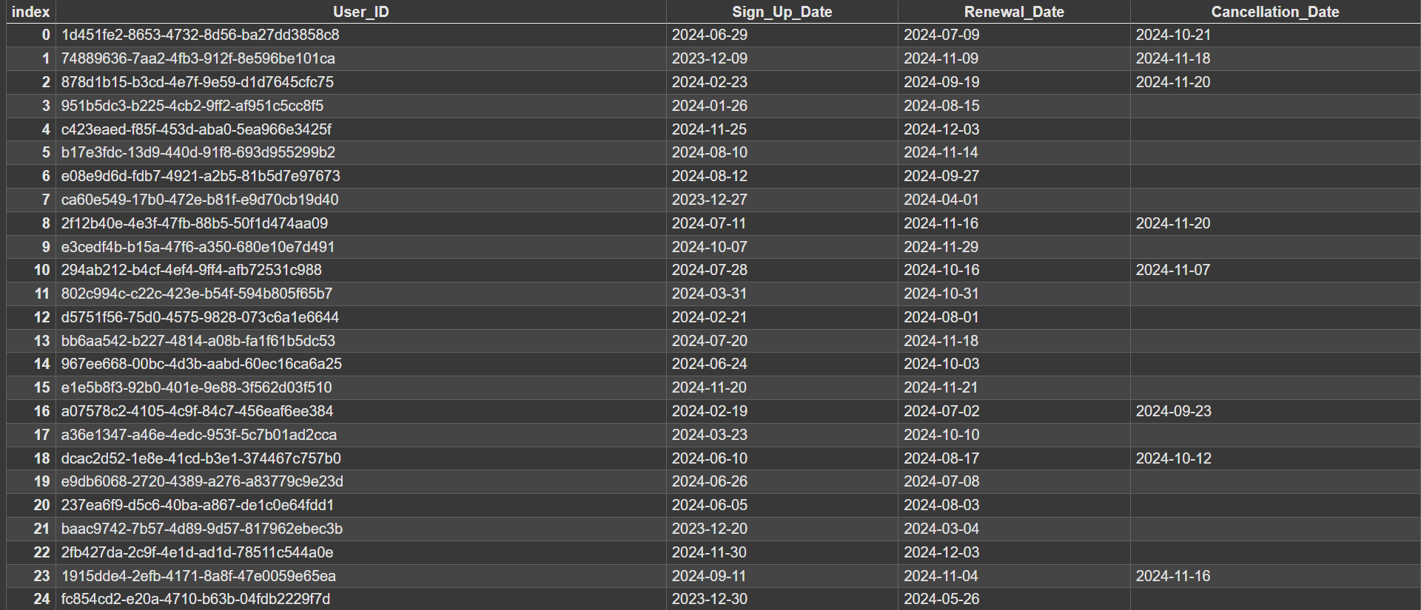

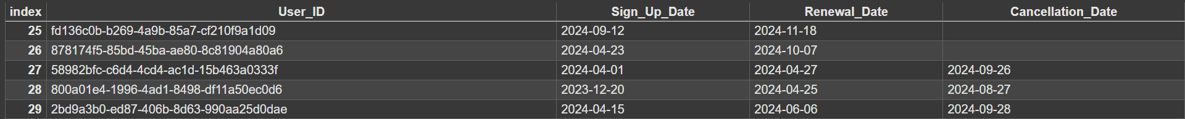

**Step 2 : Define Cohorts**

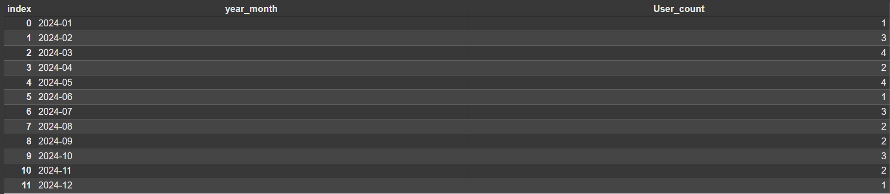

**Step 3. Tracking Metrics (Retention Rate)**

We’ll calculate the monthly retention rate for each cohort. Retention is tracked by checking whether users made transactions in subsequent months after signing up. Here’s how to calculate the retention rate for each month

|  |  |  |  |  |  |  |  |  |  |  |  |  |  |  |
| --- | --- | --- | --- | --- | --- | --- | --- | --- | --- | --- | --- | --- | --- | --- |
| Cohort | Sign ups | M-1 | M-2 | M-3 | M-4 | M-5 | M-6 | M-7 | M-8 | M-9 | M-10 | M-11 | | M-12 |
| Jan-24 | 1 | 100% | 100% | 100% | 0% | 0% | 0% | 0% | 0% | 0% | 0% | 0% | 0% | |
| Feb-24 | 3 | 100% | 66% | 66% | 33% | 33% | 0% | 0% | 0% | 0% | 0% | 0% |  | |
| Mar-24 | 4 | 100% | 75% | 75% | 25% | 25% | 25% | 0% | 0% | 0% | 0% |  |  | |
| Apr-24 | 2 | 100% | 100% | 100% | 50% | 0% | 0% | 0% | 0% | 0% |  |  |  | |
| May-24 | 4 | 100% | 75% | 75% | 25% | 25% | 25% | 0% | 0% |  |  |  |  | |
| Jun-24 | 1 | 100% | 100% | 100% | 0% | 0% | 0% | 0% |  |  |  |  |  | |
| Jul-24 | 3 | 100% | 66% | 66% | 33% | 33% | 0% |  |  |  |  |  |  | |
| Aug-24 | 2 | 100% | 100% | 100% | 50% | 0% |  |  |  |  |  |  |  | |
| Sep-24 | 2 | 100% | 100% | 100% | 50% |  |  |  |  |  |  |  |  | |
| Oct-24 | 3 | 100% | 66% | 66% |  |  |  |  |  |  |  |  |  | |
| Nov-24 | 2 | 100% | 100% |  |  |  |  |  |  |  |  |  |  | |
| Dec-24 | 1 | 100% |  |  |  |  |  |  |  |  |  |  |  | |

**Step 4: Analysis of Retention Patterns**

|  |  |  |
| --- | --- | --- |
| **Retention Pattern** | **Observation** | **Explanation** |
| High Initial Retention | Retention in the first month is 100%. | Offering high quality video experience and video download features after the subscription and also available of video without ad. |
| Gradual Drop-Off | In the third month there is a gradual drop to minimum of 65%. | This gradual decline is common in user behaviour. Early adopters may drop off if they no longer see value in repeated use |
| Retention Challenges in Month 4 | From the month 4 users started to avoid subscription | This is may be due to users comparison on the worth of their amount spend and the benefits after the subscriptions.  They are not satisfied with the benefits of subscription. |

**Step 5: Actionable Insights**

● **Retention Trends**: Analysing the retention patterns reveals that while the retention rates are high in the first month, they start to decline significantly by the second month. This suggests the need for targeted retention strategies after initial onboarding. Implement re-engagement strategies after the first month to bring users back. This could involve personalized push notifications, targeted offers, or loyalty programs to incentivize continued use. Continue engaging users through offers, discounts, or loyalty programs to maintain retention.

● **Feedback**: Collecting user feedback to identify the cause and address it through product improvements or service enhancements.

**Let's take a dataset of Phone Pe for cohort retention analytics**

|  |  |  |  |  |  |  |  |
| --- | --- | --- | --- | --- | --- | --- | --- |
| **Cohort** | **New users** | **Month 1** | **Month 2** | **Month 3** | **Month 4** | **Month 5** | **Month 6** |
| **Jan 2024** | **1500** | **800** | **700** | **600** | **500** | **400** | **300** |
| **Feb 2024** | **2000** | **1000** | **800** | **650** | **550** | **450** | **350** |
| **Mar 2024** | **1800** | **900** | **750** | **600** | **500** | **400** | **300** |
| **Apr 2024** | **2200** | **1200** | **1000** | **850** | **700** | **600** | **500** |
| **May 2024** | **2100** | **1100** | **950** | **800** | **650** | **550** | **450** |
| **Jun 2024** | **2500** | **1300** | **1100** | **900** | **800** | **700** | **600** |

**Heat Map**

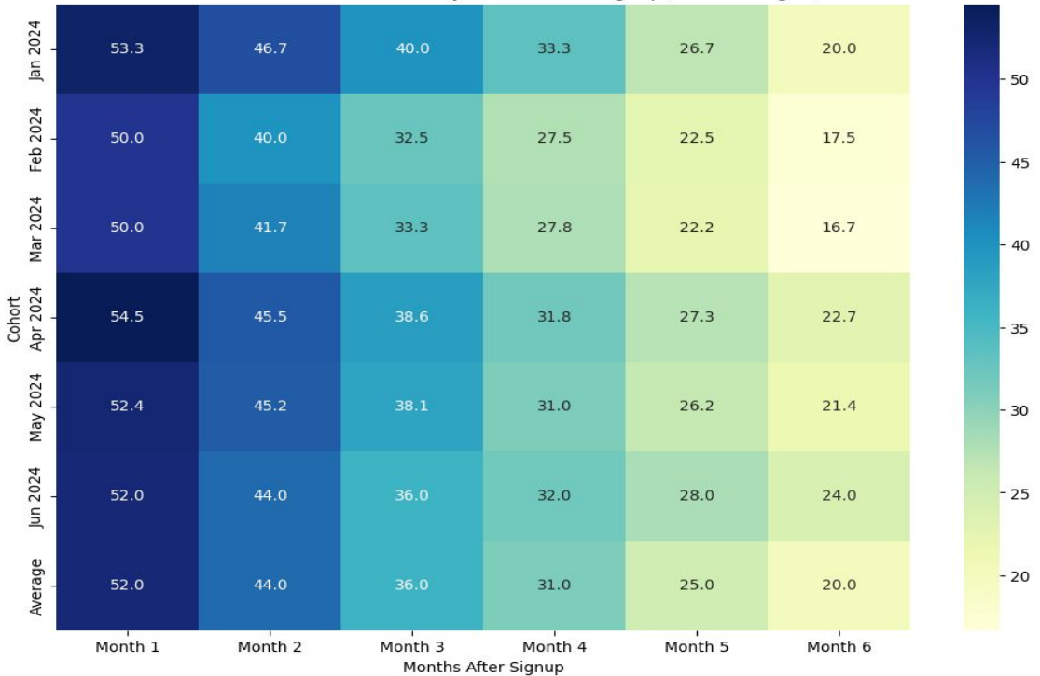

**Question 2**:  
If we find that users tend to drop off after the third month, what strategies would you propose to improve **long-term retention**?

**Possible Reasons for Retention Drop**

1. Unexpected Charges

2. Lack of Value perception

3. Confusion Between Free and Paid Features

4. Limited Features on offline downloads

5. Ad-Free Experience Expectations

6. Limited Device Support

7. High cost

**Strategies to Address the Drop-off**

1. Clear reminders before the renewal date

2. Improve messaging around premium features and their value

3. Transperant labeling of features and clearer marketing

4. Expand download permissions and improve transparency about restrictions

5. Clarify that ads within creator content are not controlled by YouTube Premium

6. Ensure broader compatibility across platforms

7. Restructure the cost of premium subscription

**Scenario 2:**

A gaming company is testing two different **tutorial designs** for new users in its mobile game. **Version A** is a brief, text-based tutorial, while **Version B** is an interactive, step-by-step guide. They want to see which tutorial leads to better **user retention** and higher **conversion rates** (i.e., users making in-game purchases).

**Question 1**:  
Design an **A/B test** to evaluate which tutorial version leads to better retention and conversion rates. What metrics would you use to measure success?

**A/B Testing for two different tutorial design for the mobile game.**

Version A – Version A is a brief, text-based tutorial

Version B - Version B is an interactive, step-by-step guide

**A/B Testing structure**

**Step 1: Define Hypotheses**

* **Null Hypothesis**: There is no significant difference in retention or conversion rates between Version A and Version B.
* **Alternative Hypothesis**: Either retention or conversion rates will differ significantly between Version A and Version B.

**Step 2: Split Users Randomly**

1. **Random Assignment**:
   * New users are randomly assigned to one of the two tutorial versions:
     + **Group A**: Users experience Version A (brief, text-based tutorial).
     + **Group B**: Users experience Version B (interactive, step-by-step

|  |  |
| --- | --- |
| Version | No of Users |
| A | 5000 |
| B | 5000 |

**Step 3: Isolation**

● Ensure the users in both groups are not influenced by external factors, such as ads, customer support interactions, or email reminders.

**Step 4: Data Collection**

|  |  |  |
| --- | --- | --- |
| **Version** | **Retention Rate** | **Conversion Rate** |
| **A** | **40%** | **20%** |
| **B** | **50%** | **25%** |

**Step 5**: Define End Period of the Experiment

● The experiment will run for 4 weeks or until statistically significant results are achieved, ensuring that both versions are displayed to a sufficient number of users to draw reliable conclusions.

**Step 6**: Analysis

From the above table the conversion rate and retention rate has a significant difference for both versions, comparing the above result version B has a 10% more retention rate than version A and also version B has a 5% more conversion rate than version A.

**Question 2**:

If **Version B** (interactive guide) shows higher conversion rates but slightly lower retention, how would you balance these results when making a recommendation to the business?

**Step 1: Assess the Trade-Off**

1. **Higher Conversion Rate in Version B**:
   * Directly contributes to short-term revenue.
   * Indicates that the tutorial effectively encourages users to spend.
2. **Lower Retention Rate in Version B**:
   * May reduce the long-term user base and lifetime value (LTV).

**Step 2: Recommendations**

1. **Short-Term Strategy**:
   * **Prioritize Version B** due to its immediate revenue benefits.
   * Implement quick refinements to improve retention (e.g., add engaging elements to the tutorial).
2. **Long-Term Strategy**:
   * Conduct user feedback sessions to understand why retention is lower.
   * Adjust Version B to incorporate elements from Version A that encourage users to stay.
     + For example, simplify the interactive guide or provide users with an option to skip steps.
   * Retest the updated tutorial (Version C) to find a balance.
3. **Analyze Retention vs. Revenue Impact**:
   * Perform a cohort analysis to calculate the lifetime value of users in both groups.
   * Compare the total revenue generated by higher conversions versus the potential loss from reduced retention.

**Conclusion**

If Version B is more profitable in the short term, launch it while iterating to address retention. Balancing revenue and user engagement is key to sustainable growth.